

**Dictionary using Linked Hash**

Software Requirements Specification (SRS) Document

Sprint Implementation

Project Timeline: **05-12-2022** to **13-12-2022**

**CONTENTS**

1. Introduction

1.1 Purpose

1.2 Intended Audience

1.3 Project scope

1.4 Project Objective

1. Overview

2.1 Assumptions and Dependency

1. System Features and Requirements

3.1 Functionality

3.2 System Requirements

3.3 System Features

4. Data Flow Diagram

4.1 DFD Level 0

4.2 DFD Level 1

4.3 Flow Chart

**1.INTRODUCTION**

The introduction of the software requirement specification provides an overview of the entire software. The entire SRS with overview description purpose, scope, tools used and basic description.

Load the words from file to main memory (Linked Hash). It provides features where the user gives the word and returns the meaning of the word.

1.1 Purpose

The purpose of this project is to provide the features where the user gives the word, and it returns meaning of the word.

The system aims at displaying the dictionary contents in alphabetical order.

This allows the provisions to Add, Delete, Edit and Save the contents of linked list to file.

1.2 Intended Audience

This project is useful for everyone to improve their communication in a better way, and it can be used to look up the meaning, spelling, grammar and pronunciation of a word.

1.3 Project Scope

This dictionary is a record of non-standard words are used. The scope of the word can, in fact, be grasped fairly, easily, simply by looking over a few the entries.

Nonetheless, the assumptions behind the choice of words must be made as clear as possible, and so it is necessary at the outset to be specific about the term ‘non-standard’.

1.4 Project Objectives

To study and analyse the existing manual production processes of dictionary. To improve flexibility of dictionary generation and provide cost effective dictionary.

2.OVERVIEW

Dictionary is a reference book containing an alphabetical list of words, with information given for each word, usually including the synonyms, meanings and it provides information about their pronunciation, grammatical forms and functions, etymologies, syntactic peculiarities, variant spellings.

Our project overview is about to load the words from file to main memory and displays entire dictionary in alphabetical order. Admin helps user to provide the required data he asks for and user can add, del, edit the words from dictionary

2.1 Assumptions and Dependency

* System should have any flavour of Linux installed
* System should have either 4GB or more RAM.
* The service is used preferably on a desktop or laptop.

3.SYSTEM FEATURES AND REQUIREMENTS

3.1 Functionality

* **User:** A user is a person who search the word in a dictionary.
* **Search:** It will give the meaning of the word in a Dictionary.
* **Modifications:**
* add (): Adding the words in the dictionary.
* del (): Delete the words in the dictionary
* edit (): Modify the words in the dictionary

* **Result:** It will give the meaning of the word, which user searched in the Dictionary.

3.2 System Requirements

* Tools to be used:
* Valgrind

3.3 System Features:

* Supportability: The system is easy to use.
* Reliability: It is reliable that can be trusted or believed because we can gain the knowledge.
* Performance: The system will work on the user’s terminal.
* Availability: User can access anywhere at any time.
* Usability: It is a reference book containing the words of a language usually alphabetically arranged with information on their forms, pronunciations, function meaning, spellings.

4.DATA FLOW DIAGRAM

4.1 DFD Level 0:

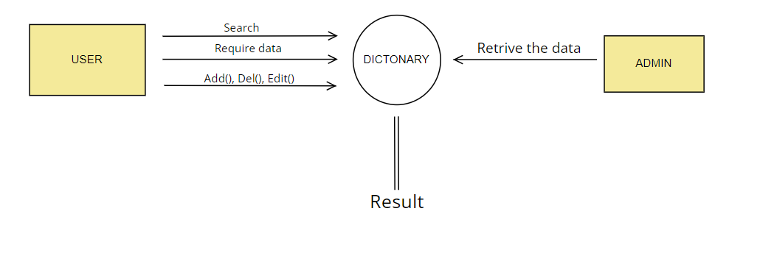

4.2 DFD Level 1:

4.3 Flow Chart:

